Ch.6 Lab 1

# Task 1

# Create a Python file named list_operations and implement the following:

# Given a list [1, 2, 3, 4, 5, 6], reverse the list and then print it.

# Given a list [4, 6, 8, 6, 12], remove all the occurrences of 6 and then print it.

# Given a list [5, 10, 15, 200, 25, 50, 20], find the value 20 in the list, and if it is present, replace it with 200. Only update the first occurrence of the value.

# Given 2 lists of strings: list1 = ["M", "na", "i", "Ke"] list2 = ["y", "me", "s", "lly"]

# Concatenate the two lists index-wise, so it becomes ['My', 'name', 'is', 'Kelly']

# 

# ***Sample output:***

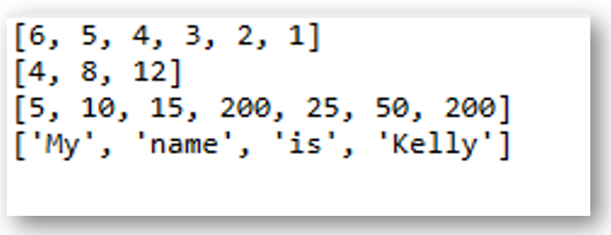

|  |
| --- |

|  |
| --- |

# Task 2

# Write a Python program that implements a function called alternating_sum, which computes the alternating sum/difference of all elements in a list. This function takes a list as a parameter.

# 

# For example, if your program reads the input:

# 1 4 9 16 9 7 4 9 11

# 

# then it computes:

# 1 – 4 + 9 – 16 + 9 – 7 + 4 = –4

# 

# 

# ***Sample output:***



  
  

  
  

 

  
  

 